Weather Observation Station 5 | HackerRank
Question:
Query the two cities in STATION with the shortest and longest CITY names, as well as their respective lengths (i.e.: number of characters in the name). If there is more than one smallest or largest city, choose the one that comes first when ordered alphabetically.
The STATION table is described as follows:
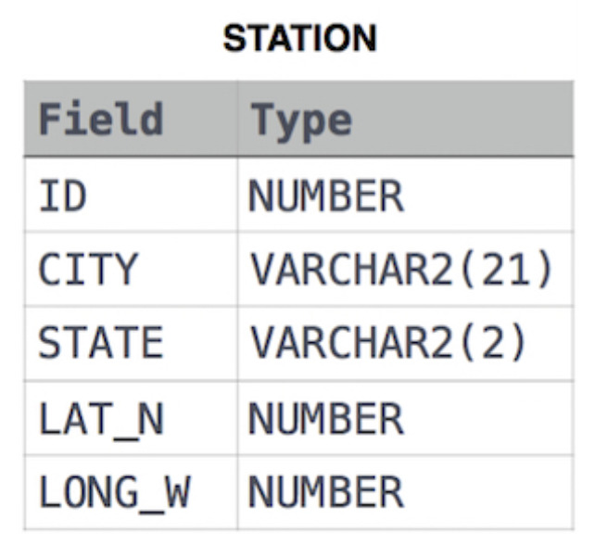
where LAT_N is the northern latitude and LONG_W is the western longitude.
Sample Input
For example, CITY has four entries: DEF, ABC, PQRS and WXY.
Sample Output
ABC 3
PQRS 4
Explanation
When ordered alphabetically, the CITY names are listed as ABC, DEF, PQRS, and WXY, with lengths 3, 3, 4 and 3. The longest name is PQRS, but there are 3 options for shortest named city. Choose ABC, because it comes first alphabetically.
Note
You can write two separate queries to get the desired output. It need not be a single query.
Answer:
(select city, length(city)
from station
where length(city) in (select min(length(city)) from station)
order by city
fetch first ROW only) UNION (select city, length(city)
from station
where length(city) in (select max(length(city)) from station)
order by city
fetch first ROW only);

